Healthcare Data analysis With Different Modules and Tools
Abstract:
Given the state of the world today, data analysis is one of the most rapidly developing and popular fields in industry, particularly in the healthcare sector. Most of the time, the unstructured format of the data in the healthcare industry makes it impossible to understand. We can obtain detailed analytical reports on various health information, such as patient details, medical details, billing details, medical conditions, age factor, gender, etc., for this type of task by using various modules and tools. There are various modules and tools available to obtain detailed information and visualizations. Common tools include databases and big data tools (SQL, NoSQL databases), programming and analytics platforms (Python, R, SAS), business intelligence and visualization tools (Power BI, Tableau), statistical analysis, machine learning, NLP (natural language processing), data mining, and data visualization. Healthcare-specific tools include EHR/EMR, HL7, FHIR, and IBM Watson Health. Analysis of healthcare data is essential for enhancing clinical judgment, streamlining processes, and improving patient outcomes. It is quite helpful for estimating the average ratio of people's ailments in a variety of disciplines, including research, education, and hospitals. After information systems and medical technology are integrated, healthcare systems will undergo a digital revolution. These methods will effectively process healthcare data and extract information about specific ailments. Through various analysis and visualization, this study reviews how to effectively apply these techniques in the real-time healthcare area to anticipate public diseases and lower healthcare service costs.

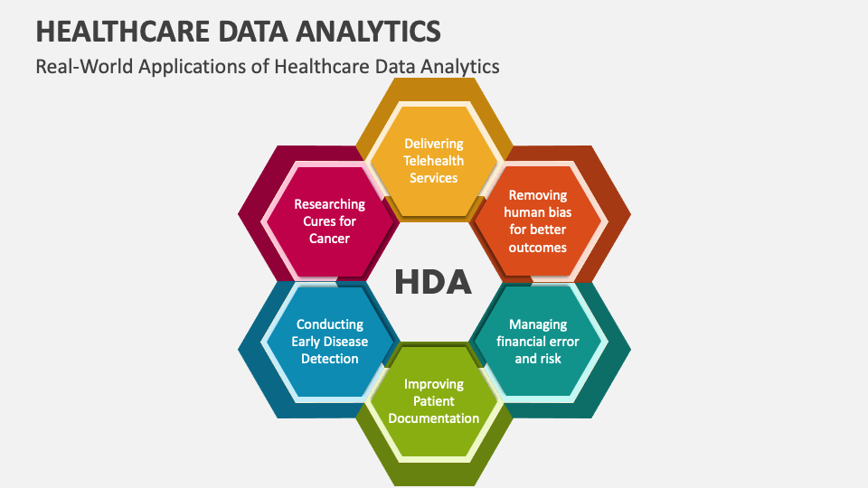
Figure 1

Keywords:
Healthcare, Data analysis, Methods, Tools, Data visualization, Data processing
Background Frameworks:
The foundation of the healthcare data analysis project involves:
- Problem Identification: Understanding key challenges related to medical bills, medical conditions, Test results, Blood Type, Blood Pressure, Sleep disorders, Stress, Physical activity, Billing, Admission Type, Test Results, age, sex, bmi, smoker, charges
- Data collection: Sourcing relevant datasets from healthcare databases, surveys or research publications.
- Data preprocessing: Handling missing values, removing duplicates, and normalizing data for consistency.
- Exploratory Data Analysis: Performing statistical summarization, trend visualization and identify correlations.
- Ethical & Privacy Considerations: Ensuring compliance with HIPAA, GDPR, and anonymization techniques for patient privacy.

Plan Of Action:

- Data Acquisition & Cleaning
- Gathering datasets from reliable sources (Kaggle, Data.Gov[US Government Open data]), GitHub.
- Preprocess data-handle missing values, remove duplicates.
- Ensure data quality checks before analysis.

- Exploratory Data Analysis (EDA)
- Use descriptive statistics (mean, median, Standard deviation) to summarize key attributes.
- Visualize data distribution using histograms, scatterplots box plots and heat maps
- Identify correlations Between sleep disorders and variables like stress level, Physical activity, Physical activity, Billing, Admission Type, Test Results, age, sex, bmi, smoker, charges

- Interpretation & Insights Generation
- Translate findings into actionable healthcare recommendations.
- Compare results with existing literature and research studies.
- Identify patterns and trends that could influence public health policies.

- Documentation & Research article writing
- Structure the research article with introduction, methodology, results, discussion and conclusion.
- Support findings with relevant citations and comparisons to prior studies.
- Present Insights in a visually appealing format using graphs and charts, matrix table.

1.Introduction:
The purpose of this paper is about to analyse the healthcare data with different healthcare datasets. The data is collected from the existed website and reviewed with different reviewed articles. The analysis has been done with the types of descriptive and diagnostic analysis is to summarize and describe the top features of the dataset and to investigate with causes of past outcomes. The collected data explores the distribution of gender and age across various occupations, while analysing relationships between different conditions and categories such as patient demographics, quality of sleep, physical activity, stress levels, BMI categories, hospital billings, medical conditions, and departments. By examining these factors, the study aims to identify significant correlations, offering deeper insights into how these variables interact and impact one another. The key features of this paper include generating accurate healthcare analytical reports, performing data cleaning to handle duplicates and missing values, and conducting exploring data analysis using effective tools and programming modules.

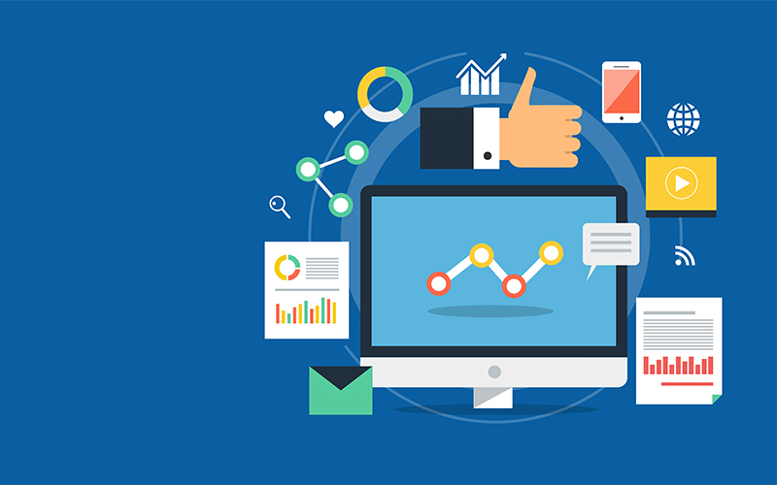
Figure 2

2. Benefits:
The principal benefits of healthcare data analysis are in advancing patient care, perfecting the quality and effectiveness of healthcare delivery and furnishing sapience into how cases interact with their providers.
Some benefits of using data analytics include perfecting:
- Quality of patient care by relating and precluding medical crimes across all departments, similar as surgery or laboratory testing.
- Treatment issues by using data from electronic health records (EHRs) to determine which treatments work stylish for specific cases.
- Cost and profit by streamlining force and staffing issues.
- Supporting the work of medical labor force by use of data analytics and intelligent data results is critical for supporting clinicians in colorful ways.
- Supporting scientific and exploration exertion by advanced analytics supports scientific and exploration exertion ways, enabling experimenters to work more efficiently and effectively.
- Business and operation by data analysis has proven to be a precious tool for reducing costs and precluding abuse and fraudulent practices.
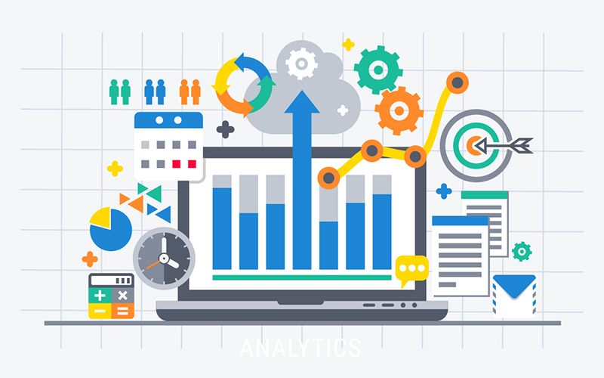

Figure 3
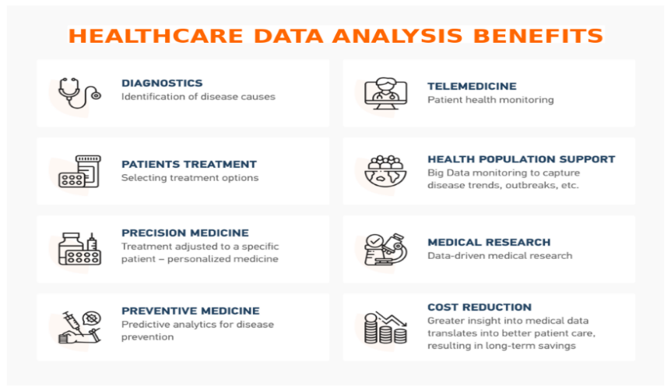
Figure 4

Motivation and Scope:
The motivation and scope of conducting this research is about, understanding the scope of healthcare data analytics is vital. It involves extracting insights from vast amounts of healthcare data to improve patient outcomes, operational efficiency and decision-making process and advanced medical research. Perusing MSC Health Informatics and Analytics is recommended for those aiming to specialize in this field. The scope of this paper is giving detail analytical reports on healthcare unstructured data and to reduce their cost and improve the services, identifying patients with chronic diseases by understanding the disease pattern of many patients, and avoiding human errors by using healthcare data tools and methods to reduce errors and prevent epidemics. healthcare players are trending towards the data analytics. The data analytics in healthcare focusing on medical bill data, gender data, age data, occupational data, different conditions and different medical departments data.

3.Methodology:
The aim of this research, we followed different methods and tools is find out best results on healthcare. The methods are descriptive analysis, diagnostic analysis and data cleaning. The tool are Python Pandas, NumPy, Mat plot, Seaborn, Power BI, SQL, MS Excel.
The methods are for to summarize and describe the main feature of the dataset and investigate the past outcomes and find out duplicates and transform the data in uniform manner (Eg: -Averages, Totals, Percentages, Root cause analysis, Correlation analysis).
Datasets:
- Sleep health and Lifestyle dataset (Kaggle, csv)
- Healthcare dataset (Kaggle, csv)
- Medical data dataset (GitHub, csv)
Tools:
- Python Libraries:
- Pandas: Organization patient records and Filtering patient visits by diagnosis.
- NumPy: Performing statistical calculations on patient vital
- Matplotlib and Seaborn: Plotting trends in disease outbreaks and visualizing patients age distributions, lab results etc.
- SQL (Structured Query Language): Retrieves data on patients, Treatments. Diagnosis.
- Power BI: Visualizing overall reports.
- Microsoft Excel: Analyzing small data sets without code.
Steps:
- Data processing and Data loading.
- Handling missing data.
- Data visualization
- Correlation analysis
- Dashboard Creation,
- Summary analysis

4. Challenges:
Data analytics has come an essential tool for perfecting patient issues and driving invention in the assiduity. still, there are significant challenges to enforcing effective data analytics for healthcare associations.
Understanding the challenges of using patient data in clinical data analytics is critical for realizing the implicit benefits of data analytics.
• Data Structure Issues:
In healthcare, utmost data is unshaped, frequently stemming from natural language processing. This data is generally fractured, dispersed, and lacks standardization.
• Missing Data and Data Sparsity:
In healthcare, missing electronic medical records (EMR) data can arise due to inadequate data collection or lack of attestation. The former occurs when cases are n't screened for a specific medical point. also, data sparsity exacerbates the problem, as cases only visit the hospitals many times and only a many medical features are generally recorded.
Fortunately, there are several ways for handling missing data and sparsity, similar as insinuation styles.
• Security Issues:
Data analytics in healthcare pose significantly sequestration enterprises, particularly with the enactment of the Health Insurance Portability and Responsibility Act (HIPAA) legislation. Making healthcare data available on open- source platforms increase its vulnerability to implicit breaches.
• Data Standardization Issues:
Healthcare association generally use electronic health record (EHR) systems to store and partake patient data within their own network. still, the lack of standardization and comity between EHR platforms within an association and outside of it poses a significant challenge for data analytics.
Data stored in non-compactible formats and lack of standardization make data accession and drawing a complicated process.
colorful norms development association similar as Health Level Seven International( HL7), developed norms that give for global health data interoperability with thing of working the lack of data standardization in healthcare. HL7 norms, similar as FHIR (Fast Healthcare Interoperability coffers).
• Data Irregularity
1. EMR Data Challenge Electronic Medical Records (EMR) are irregular because data is recorded only during sanitarium visits.
2. Longitudinal Matrix EMR forms a patient matrix with uneven time intervals and varied medical features, complicating analysis.
3. birth Features Used to homogenize patient histories for comparison across patient groups.
4. Data Transformation Converts irregular data into regular time- series via interpolation or insinuation.
5. Direct Modelling Some models can handle irregular time- series data without metamorphosis.
6. UCUM Conversion homogenizing time- series data into UCUM ensures thickness in dimension units.
7. system Choice Selection depends on logical pretensions and data characteristics.
• Data Storage and Transfers
1. High-Cost Data storehouse, security, transfer, and analysis are more precious than data generation.
2. Structured vs. unshaped Data Structured data is easier to manage; unshaped data (e.g., clinical notes, images) is harder to dissect.
3. Cloud Security Cloud systems add security layers for handling patient data during ETL (Excerpt, transfigure, cargo).
4. Analytics Challenges unshaped data analysis requires advanced styles like NLP, textbook mining, and image recognition.
5. Cost & Security Data analytics should help reduce costs and insure secure data transmission.

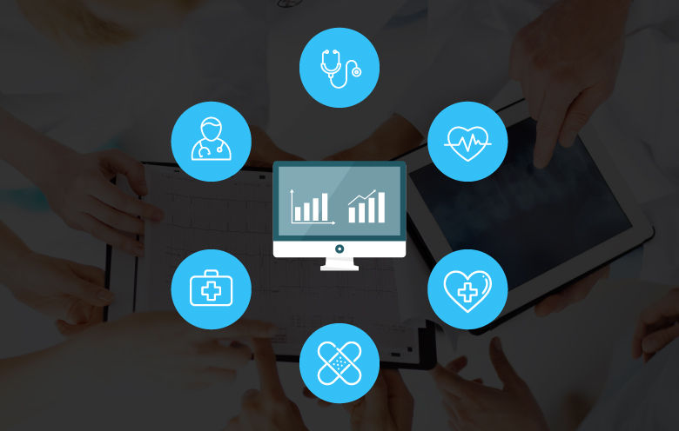
Figure 5

5.Results:

1. Sleep Health and Lifestyle Dataset
Dataset of Sleep health and lifestyle dataset collected from Kaggle database
Data Analysis with Pandas, seaborn, matplotlib, NumPy:
- 374 entries
- Key columns: Sleep Duration, Quality of Sleep, Physical Activity Level, Stress Level, BMI Category, Sleep Disorder
Use for:
- Correlation studies (e.g. stress vs sleep)
- BMI vs occupation
- Sleep disorders vs lifestyle factors

- Gender Distribution by barplot:
- Male: 189 patients (blue)
- Female: 185 patients (pink)
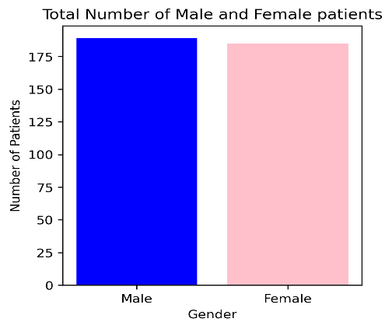

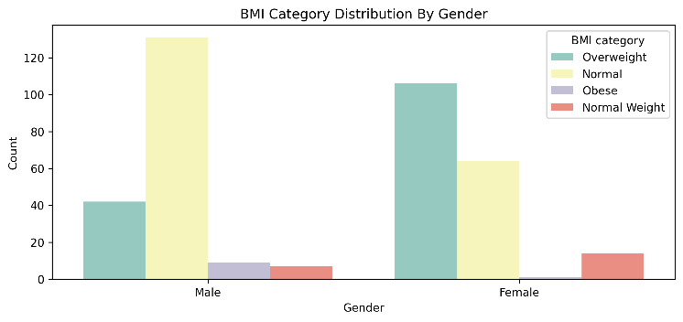
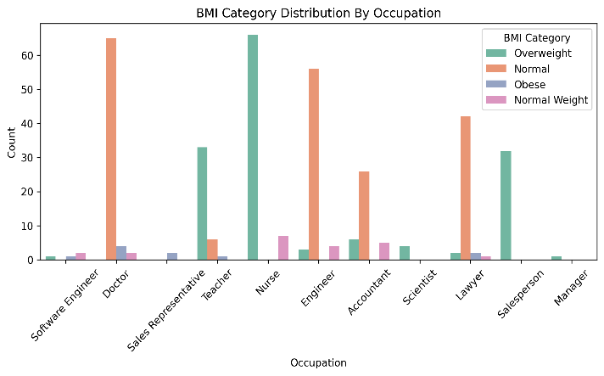
- BMI category distribution varies by occupation and gender:

- Findings from BMI Category Distribution by Occupation (Count plot):
- Nurses and Teachers have a high proportion of individuals with Normal BMI:
  - This might suggest that people in caregiving or educational roles may be more aware or conscious of health and wellness.
- Doctors and Engineers show a predominance of Overweight BMI category:
  - Despite being in the medical field, doctors may have demanding schedules that impact physical health.
  - Engineers may have sedentary jobs, leading to increased overweight proportions.
- Software Engineers and Lawyers also show a high overweight count, suggesting:
  - Possible links between desk-bound, high-stress jobs and unhealthy BMI levels.
- Very low Normal Weight and Obese categories in occupations like Sales Representatives, Scientists, and Managers:
  - This could either be due to fewer data points or skewed lifestyle habits within these professions.

- Findings from BMI Category Distribution by Gender (Count Plot):
- Females tend to have higher Overweight rates, while males have higher Normal BMI counts:
  - This may indicate gender-based differences in physical activity, metabolism, or lifestyle choices.
- Obesity is more present in Females:
  - While not as frequent as other categories, the trend is notable and might reflect social or healthcare access differences.
- Males show a wider distribution across BMI categories (especially more individuals in the Normal and Normal Weight categories), while females are more concentrated in Overweight and Obese:
  - Points to a possible gender disparity in weight management or health interventions.
- General Observations:
- Overweight is the most frequent BMI category across both dimensions (occupation and gender).
- Normal Weight is significantly underrepresented across the board.
- Lifestyle, work environment, and gender roles may play a significant part in influencing BMI.

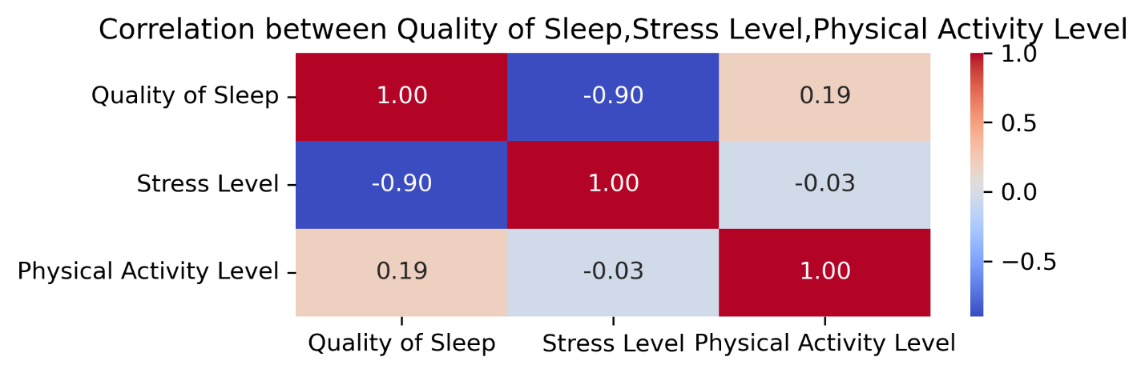
correlations between "Quality of Sleep," "Stress Level," and "Physical Activity Level"

- Correlation Analysis (Heat map):
Variable Pair | Correlation Coefficient | Interpretation
Quality of Sleep vs Stress Level | -0.90 | Strong negative correlation – higher stress leads to poor sleep quality.
Quality of Sleep vs Physical Activity | 0.19 | Weak positive correlation – increased physical activity may slightly improve sleep quality.
Stress Level vs Physical Activity | -0.03 | Negligible correlation – almost no relation between stress and physical activity.

- Key Insights from the Heatmap:
- High Negative Correlation Between Sleep and Stress:
  - A coefficient of -0.90 indicates that as stress levels increase, quality of sleep decreases significantly.
  - This is a crucial finding for healthcare interventions—managing stress may be a key lever to improving sleep.
- Minimal Relationship Between Stress and Physical Activity:
  - The correlation of -0.03 shows almost no impact of physical activity on stress level in this dataset.
  - Suggests that while exercise is beneficial, it may not be sufficient alone to reduce stress.
- Weak Positive Effect of Physical Activity on Sleep Quality:
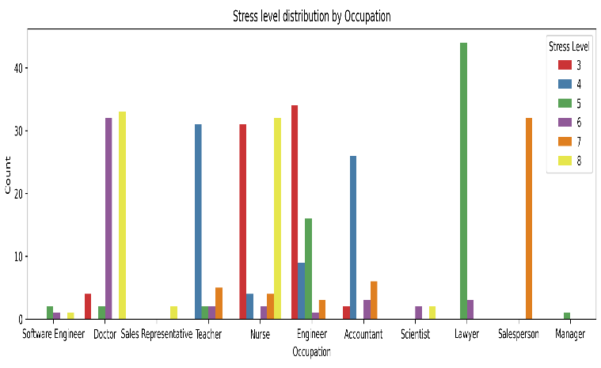
  - A 0.19 correlation suggests that physical activity might contribute to better sleep, but other factors likely play a stronger role.
1. Stress Level Distribution by Occupation (Count plot)
Key Observations:
- Lawyers exhibit very high stress levels, especially level 5 (green), with little representation in lower stress categories.
- Doctors and Nurses also show a high count in stress levels 6 and 7, indicating a demanding and high-pressure work environment.
- Teachers have relatively lower stress, mostly concentrated in levels 3 and 4.
- Sales Representatives, Engineers, and Accountants show more balanced distributions across mid-stress levels (4–6).
- Software Engineers and Scientists have smaller distributions, possibly due to fewer data points or lower stress variability.
Insight:
High-stress levels are strongly associated with caregiving and legal professions. Jobs with critical decision-making, long hours, or emotional labor—such as doctors, lawyers, and nurses—report higher stress intensity.

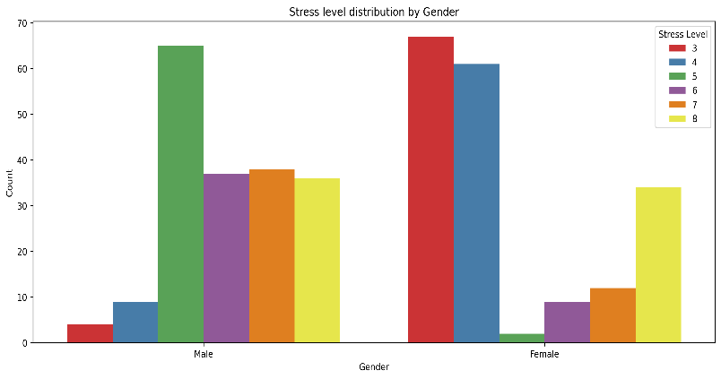

2. Stress Level Distribution by Gender (Count plot)
Key Observations:
- Females show peak stress levels at 3 and 4, suggesting lower perceived stress overall.
- Males show the highest stress at level 5, and substantial counts at levels 6, 7, and 8 as well.
- Females have lower frequency at higher stress levels (6–8) compared to males.
Insight:
Stress appears to be more intense among males, possibly due to occupational roles or societal pressures. Females, while still affected by stress, show a distribution skewed toward the lower end of the stress spectrum.

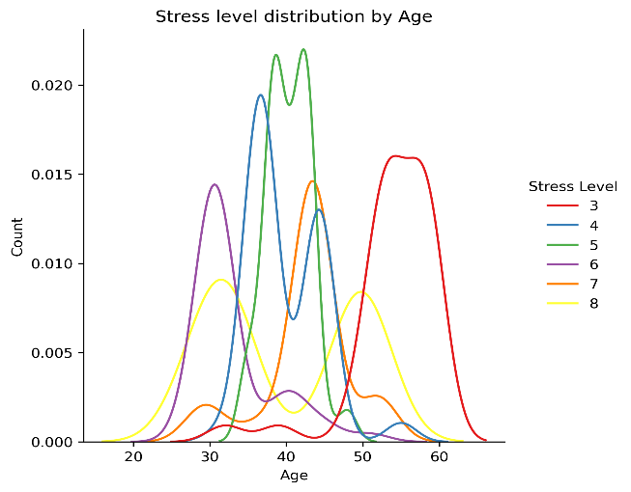

3. Stress Level Distribution by Age (Dis plot)
Key Observations:
- Age 30–40: Dominant range for stress levels 4, 5, and 6, showing peak working-age individuals face significant stress.
- Age 40–50: A mixture of medium to high stress levels (5 to 7).
- Above 55 years: Strong rise in stress level 3, suggesting lower stress in older individuals, possibly due to retirement or reduced responsibilities.
- Younger individuals (20s) have minor representation, with small peaks in stress levels 6 and 7.
Insight:
The most stressful life phase is between 30 and 50 years, aligning with prime career, family, and financial responsibility periods. Stress drops notably after age 55, indicating life stabilization or reduced work intensity.

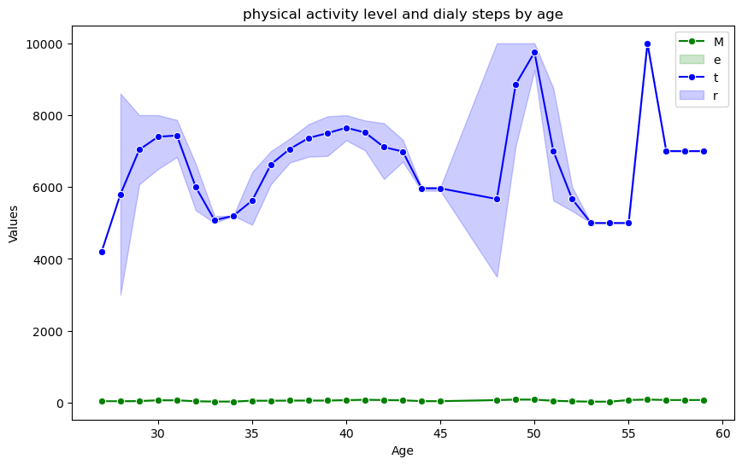

- Understanding the Line Chart:
- X-axis: Age (from 28 to 59 years).
- Y-axis: Values representing:
  - Blue line (t): Daily step count.
  - Green line (M): Physical activity level.
- Shaded area: Represents variability (standard deviation or confidence interval) in daily steps.

- Key Observations:
1. Daily Steps (Blue Line):
- Highly variable across ages.
- Peaks around:
  - Age 30–32
  - Age 38–40
  - Sharp rise again around 48–50
- Troughs (lowest activity) around:
  - Age 34–35
  - Age 44–46
  - Age 52–54

2. Physical Activity Level (Green Line):
- Remains almost flat and low across all age groups.
- Slight uptick between ages 46–52, but still close to baseline

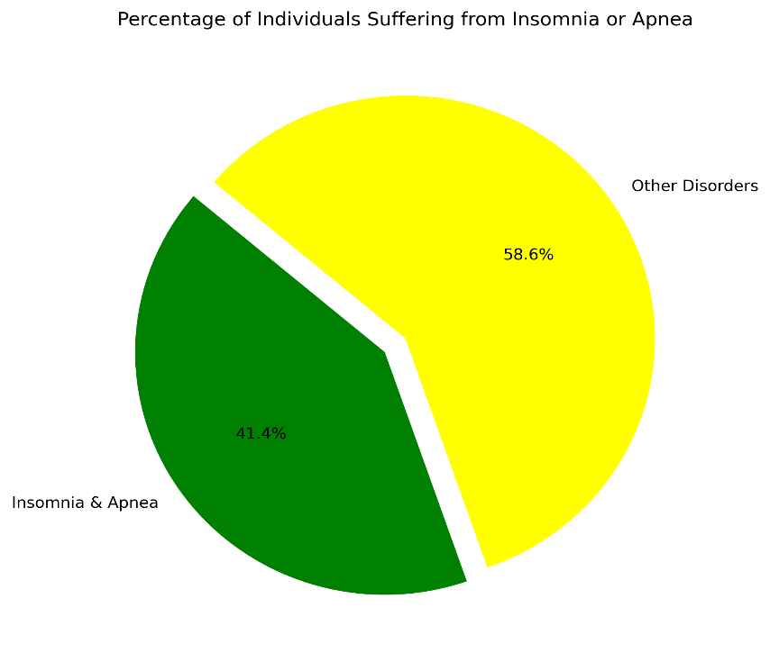
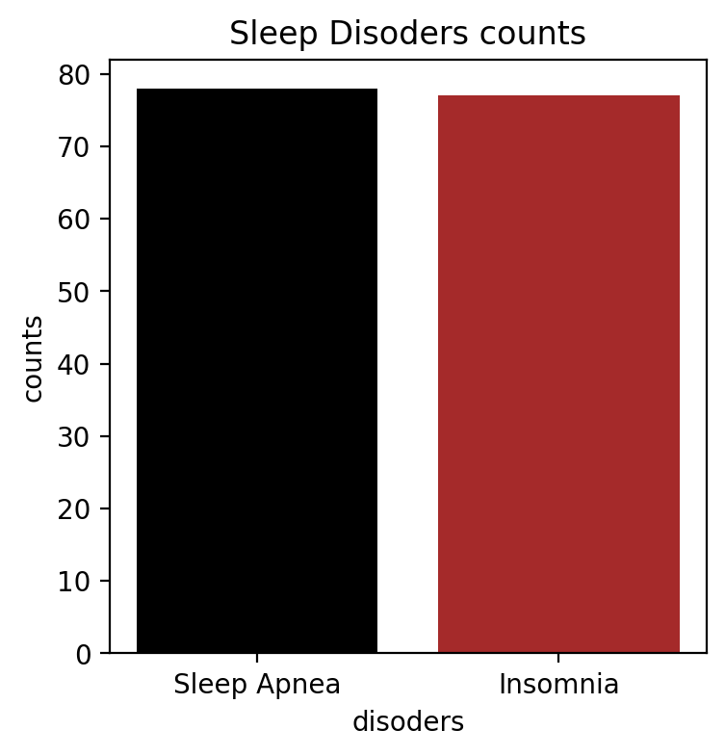
Sleep Disorders:
- Sleep Apnea = 78
- Insomnia = 77
- None = 219

1. Overall Distribution of Sleep Disorders:
Pie Chart - “Percentage of Individuals Suffering from Insomnia or Apnea”:
- 41.4% of individuals suffer from Insomnia or Sleep Apnea.
- 58.6% of individuals have Other Disorders (or no major sleep disorder).
Interpretation:
- A significant portion (almost half) of the population is affected by critical sleep disorders, indicating sleep issues are prevalent and concerning.

2. Count of Each Sleep Disorder Type:
Bar Chart - “Sleep Disorders Counts”:
- Sleep Apnea and Insomnia have nearly equal distribution (≈ 78 each).
Interpretation:
- There is a balanced presence of both disorders in the dataset, suggesting that both need equal attention from a healthcare intervention standpoint.

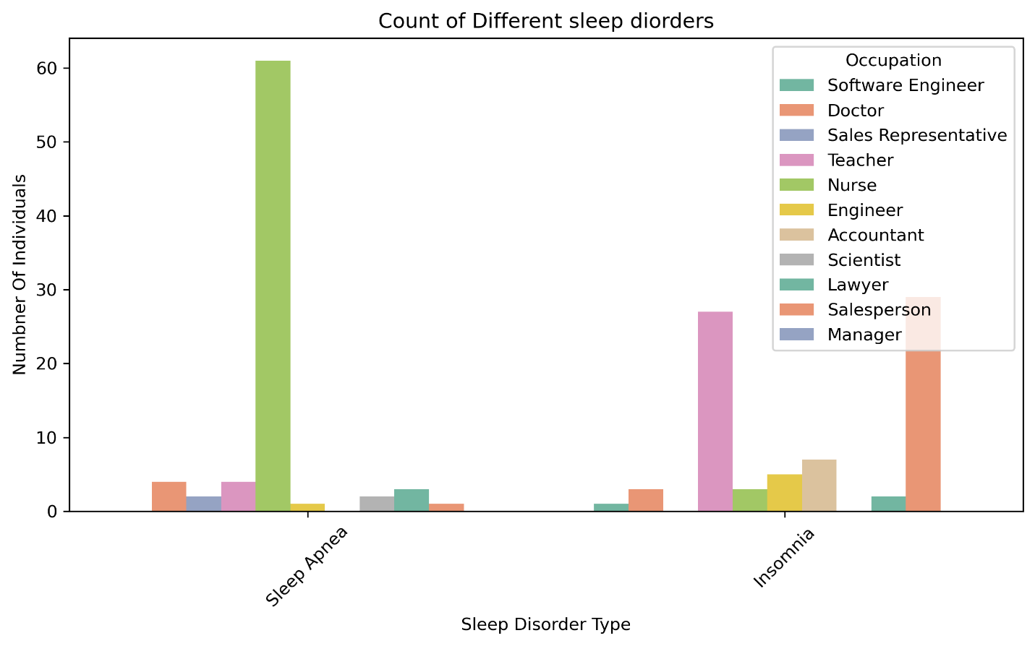
3. Sleep Disorders by Occupation
Count Plot - “Count of Different Sleep Disorders by Occupation”:
Sleep Apnea Findings:
- Nurses have the highest count (≈ 60 cases) of Sleep Apnea.
- Other affected occupations include: Doctors, Teachers, Software Engineers, Scientists.
Insomnia Findings:
- Teachers and Salespersons show high cases of Insomnia (≈ 25–30).
- Followed by Engineers, Accountants, Lawyers.
Interpretation:
- Nurses may face physical fatigue and irregular shifts, leading to higher Sleep Apnea.
- Teachers and Salespersons could be experiencing high mental workload or stress, which aligns with higher Insomnia cases.
- Sleep disorders are occupation-specific, likely tied to stress levels, work hours, and activity patterns.

Key Takeaways:
- Prevalence:
  - Over 40% of individuals suffer from either Insomnia or Sleep Apnea.
  - Both disorders are almost equally prevalent.
- Occupational Risk:
  - Nurses are at high risk of Sleep Apnea, possibly due to shift work and physical exhaustion.
  - Teachers and Salespersons are at higher risk for Insomnia, likely due to stress and cognitive fatigue.
- Public Health Implication:
  - Tailored occupational health programs should be implemented.
  - Employers and health professionals should focus on early screening and behavioural interventions for high-risk occupations.
- Correlation with Previous Charts:
  - Earlier plots showed high stress levels among certain occupations (e.g., nurses, teachers).
  - The connection between stress and insomnia is validated by this distribution.

- Healthcare Dataset
- Dataset collected from Kaggle database.
- Data analysis with Power BI.
- 55,500 entries
- Key columns: Medical Condition, Billing Amount, Gender, Hospital, Admission Type, Blood Type, Test Results
Use for:
- Billing analysis by condition, gender, and admission type
- Common diseases and their medical/financial patterns
- Hospital-based performance trends

Analysis of the Uploaded Power BI Dashboard

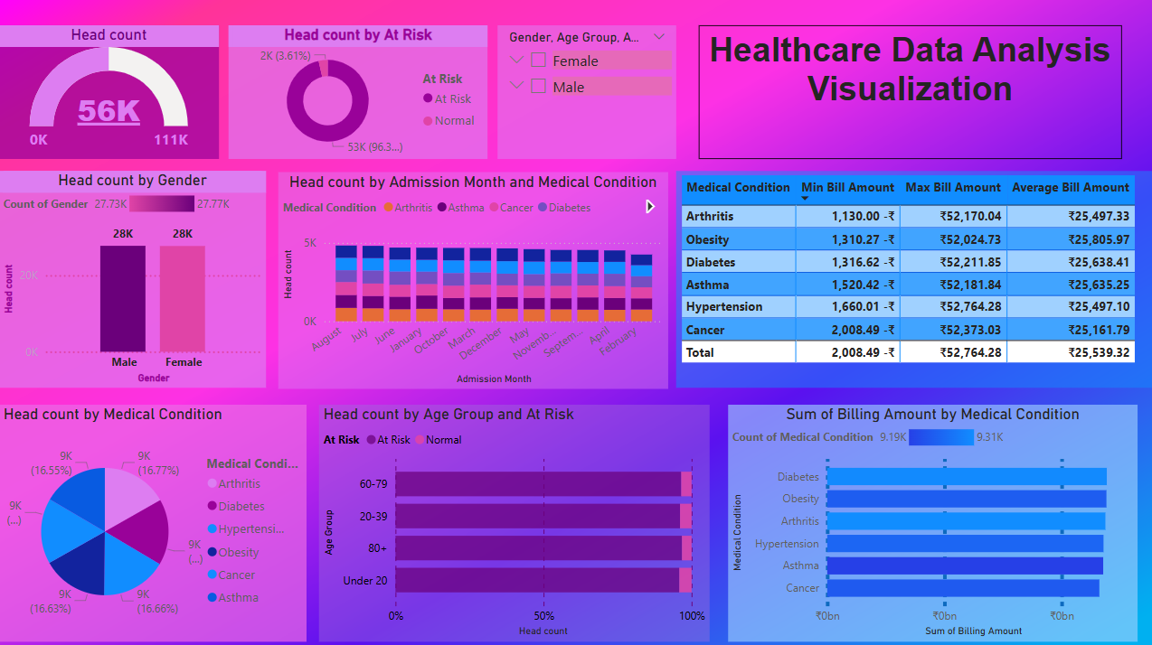

Analysis of the Uploaded Power BI Dashboard
- Overall Patient Head Count
- Total Patients: 56K
- At Risk Patients: 2K (3.61%)
- Normal Patients: 53K (96.3%)
- Insight: A very small proportion of patients are marked “At Risk” – 3.61%. Majority are categorized as normal.

- Head Count by Gender
- Male Patients: 28K
- Female Patients: 28K
- Insight: The gender distribution is perfectly balanced — equal number of males and females.

- Head Count by Admission Month and Medical Condition
- Monthly Trend: Admissions remain fairly consistent throughout the year.
- Top Conditions in All Months:
  - Diabetes
  - Cancer
  - Asthma
  - Arthritis
  - Hypertension
  - Obesity
- Insight: There is no specific seasonal pattern; patients for chronic conditions are consistently admitted across all months.

- Head Count by Medical Condition (Pie Chart)
- Conditions share approximately equal distribution:
  - Arthritis – 9K (16.55%)
  - Diabetes – 9K (16.77%)
  - Hypertension – 9K (16.63%)
  - Obesity – 9K (16.63%)
  - Cancer – 9K (16.63%)
  - Asthma – 9K (16.77%)
Insight: Each medical condition contributes roughly equally to the total patient count. This shows a broadly distributed health burden across diseases.

- Head Count by Age Group and Risk
- Age Groups Distribution (with “At Risk” in pink):
  - 60–79 Age Group shows slightly higher percentage of “At Risk” individuals.
  - Other Age Groups (Under 20, 20–39, 40–59): Majority are Normal.
- Insight: Older patients (60-79) have relatively higher risk, aligning with general healthcare trends.

- Billing Information (Table):
Medical Condition | Min Bill (₹) | Max Bill (₹) | Average Bill (₹)
Arthritis | 1,130 | 52,170 | 25,497
Obesity | 1,310 | 52,024 | 25,805
Diabetes | 1,316 | 52,211 | 25,638
Asthma | 1,520 | 52,181 | 25,635
Hypertension | 1,660 | 52,764 | 25,497
Cancer | 2,008 | 52,373 | 25,161
TOTAL | 2,008 | 52,764 | 25,539

- Insight:
- Average Bill is around ₹25.5K for almost all conditions.
- Hypertension has the highest maximum bill of ₹52,764.
- Cancer shows the highest minimum bill (₹2,008), indicating potentially more severe baseline treatment needs.

- Sum of Billing Amount by Medical Condition (Bar Chart)
- Top Conditions by Billing Amount:
  - Diabetes
  - Obesity
  - Arthritis
  - Hypertension
  - Asthma
  - Cancer
- Insight: Diabetes generates the highest overall billing amount, meaning it could be a major focus for cost management and patient care programs.

- Medical Data Dataset:
- The dataset collected from GitHub database.
- Data analysis with MySQL.
- 1,000 entries.
- Key columns: age, sex, bmi, smoker, charges.
Use for:
- BMI and cost impact.
- Smoking and billing.
- Gender/age cost distribution.

6.Literature Review:

The study of this research article is about to conduct different analysis methods and tools for healthcare data analysis:

Topic | Google Scholar Search Query | Example Use in Article
Sleep and stress | "Sleep duration and stress level correlation" | Supports correlation analysis in Sleep dataset
BMI and Medical Cost | "BMI impact on healthcare charges" | Validates BMI vs billing in medical dataset
Billing by Disease | "Billing analysis by medical condition" | Supports Healthcare dataset billing breakdown
Visualization Tools | "Power BI in healthcare data analytics" | Supports your use of Power BI for insights

1. Sleep Duration and Perceived Stress Using Python:
A study analysing data from the 2017 Community Health Survey in Korea found a significant correlation between shorter sleep durations and higher perceived stress levels among adults. Notably, individuals sleeping less than the recommended 7–9 hours reported increased stress, with younger adults and women being more affected.

2. Impact of BMI on Healthcare Costs Using MySQL:
Research from the Trøndelag Health Study in Norway demonstrated a positive association between higher BMI and increased healthcare costs. Specifically, each unit increase in BMI was linked to higher annual medical expenses, emphasizing the economic burden of obesity on healthcare systems.

3. Healthcare Data Analytics Using Power BI:
A study highlighted the effectiveness of using Microsoft Power BI for healthcare data analytics. By systematically collecting and transforming patient-related data, Power BI facilitated improved patient engagement, health system management, diagnosis, and cost reduction

References:

- Introduction figure 2 : https://www.infosysbpm.com/blogs/web-social-analytics.html

- https://www.usfhealthonline.com/resources/healthcare-analytics/benefits-of-data-analytics-in-healthcare/

- Benefits figure 3: https://www.infosysbpm.com/blogs/web-social-analytics/healthcare-data-analytics-benefits.html

- Benefits figure 4: https://kodjin.com/blog/data-analytics-in-healthcare-challenges-and-solutions/

- Motivation and Scope: https://www.quora.com/What-is-the-scope-of-healthcare-data-analytics-Is-it-recommended-to-do-an-MS-in-healthcare-analytics

- Challenges:https://kodjin.com/blog/data-analytics-in-healthcare-challenges-and-solutions/

- Figure 5: https://www.softwebsolutions.com/resources/challenges-in-healthcare-analytics.html

- SleephealthandLifestyledataset:https://www.kaggle.com/datasets/uom190346a/sleep-health-and-lifestyle-dataset

- Healthcare dataset: https://www.kaggle.com/datasets/prasad22/healthcare-dataset

- Medical data dataset: https://github.com/Scipio94/Personal-Medical-Cost-Data-Analysis/blob/main/Medical_Data_Dataset.csv

- Lee, E. H., & Kim, Y. H. (2019). The Relationship between Sleep Duration and Perceived Stress: Findings from the 2017 Community Health Survey in Korea. International Journal of Environmental Research and Public Health, 16(17), 3208. https://www.mdpi.com/1660-4601/16/17/3208?

- Kinge, J. M., & Øverland, S. (2024). The healthcare costs of increased body mass index–evidence from The Trøndelag Health Study. Health Economics Review, 14(1), 12. BioMed Central

- Sharma, N., & Sarkar, D. (2022). Healthcare Data Analytics Using Power BI. International Journal of Software Innovation, 10(1), 1–10.

- Real world applications of healthcare data analytics figure1: https://www.collidu.com/presentation-healthcare-data-analytics

